Commond of Skill
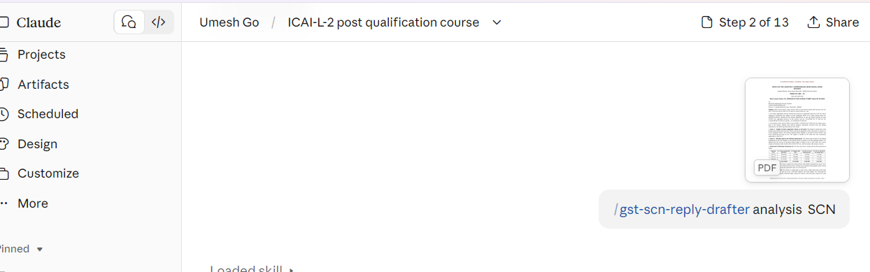

ASK information by skill before processing on SCN
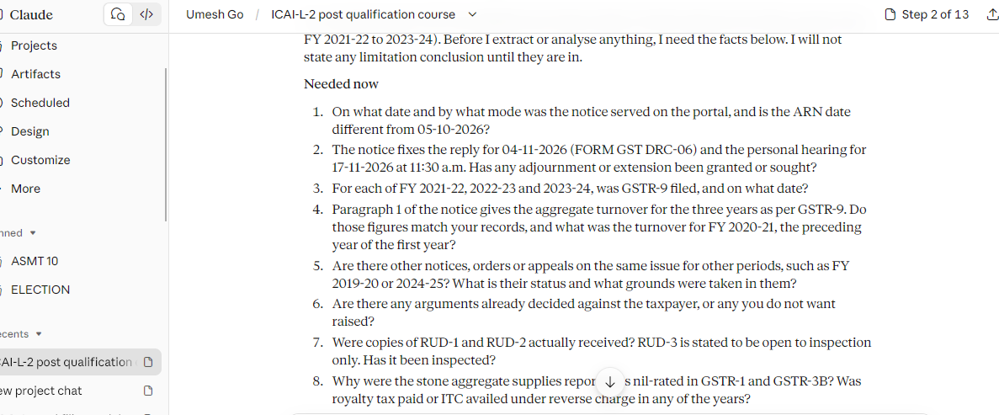

Skill reply with data one of SS
